Student Performance Prediction System

Project Id: AIML-5

Name : Anushka Tiwari (Team Leader)
Class Roll Number: 36
University Roll Number : 2028657
Section and Group: Q G1

Name : Sneha Rawat
Class Roll Number: 17
University Roll Number : 2028500
Section and Group: Q G1

TABLE OF CONTENTS
- Problem Description 3
  - Dataset Description 3
  - Flow diagram 4
- Modules for Project Implementation…………………..…………………………5
  - Modules Used 5
  - Platform Used 6
- Machine Learning model/ Searching Technique used 7
- Evaluation metrics used 8
- Results and Visualizations 9
- Conclusion and Future Scope 11
- References 12

- Problem Description
The Credit Card Fraud Detection System is a Python-based machine learning application developed to identify fraudulent credit card transactions automatically. The system analyzes transaction details and predicts whether a transaction is legitimate or fraudulent using machine learning algorithms.
The project reduces manual verification efforts and improves fraud detection accuracy using data preprocessing, feature engineering, machine learning models, and evaluation metrics. The system helps financial institutions minimize financial losses and enhance transaction security.

1.1 Dataset Description
The dataset used in this project contains transaction details such as transaction amount, merchant details, location details, transaction time, customer information, and fraud labels.
Dataset Features:
- merchant – Merchant name
- category – Transaction category
- amt – Transaction amount
- city – Customer city
- state – Customer state
- lat, long – Customer coordinates
- city_pop – City population
- job – Customer occupation
- dob – Date of birth
- merch_lat, merch_long – Merchant coordinates
- is_fraud – Fraud label (0 = Legitimate, 1 = Fraud)

1.2 Flow Diagram
Flow of Project:
- Data Collection
- Data Preprocessing
- Feature Engineering
- Encoding and Scaling
- Model Training
- Prediction
- Evaluation

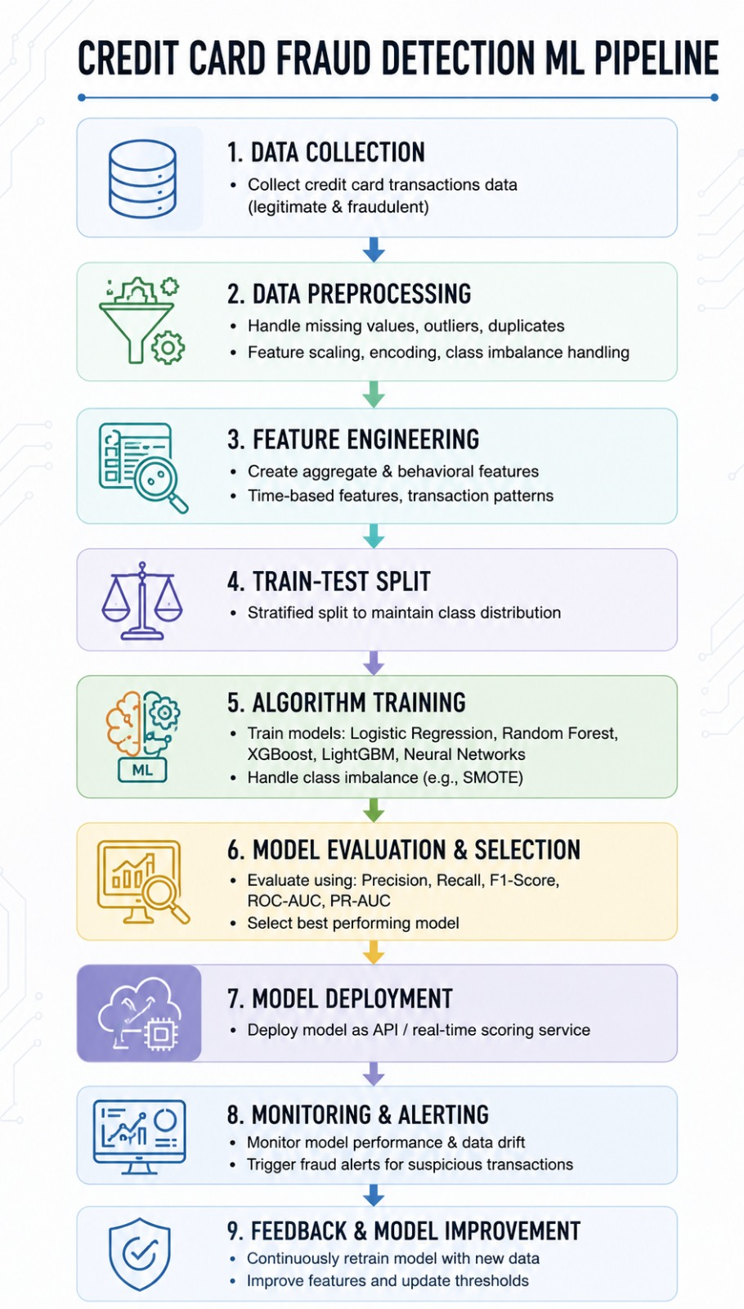
Fig.1 Sample flow diagram.

Modules for Project Implementation

2.1 Modules Used
1. Pandas
Pandas is used for data manipulation and analysis.
Functions Used:
- pd.read_csv() – Reads CSV file
- df.head() – Displays first rows
- df.info() – Shows dataset information
- df.describe() – Statistical summary

2. NumPy
NumPy is used for numerical computations.
Functions Used:
- np.where() – Conditional replacement
- np.array() – Array operations

3. Matplotlib
Matplotlib is used for data visualization.
Functions Used:
- plt.boxplot() – Displays boxplots
- plt.show() – Displays graph

4. Scikit-learn
Scikit-learn is used for machine learning algorithms and preprocessing.
Modules Used:
- LogisticRegression
- KNeighborsClassifier
- SVC
- StandardScaler
- train_test_split
- LabelEncoder

2.2 Platform Used
Visual Studio Code
Used for writing, debugging, and executing Python programs.
Jupyter Notebook
Used for step-by-step execution, visualization, and testing machine learning models.
Python
Programming language used for implementing the project.

3. Machine Learning Models Used
3.1 Logistic Regression
Logistic Regression is a supervised machine learning algorithm used for binary classification. It predicts whether a transaction is fraudulent or legitimate.
Advantages:
- Fast and efficient
- Suitable for binary classification
- Easy to interpret
Code:
from sklearn.linear_model import LogisticRegression
from sklearn.model_selection import train_test_split
from sklearn.metrics import accuracy_score, confusion_matrix, classification_report
# Train-test split
X_train, X_test, y_train, y_test = train_test_split(
X_scaled, y, test_size=0.2, random_state=42
)
# Model
lr_model = LogisticRegression(max_iter=1000)
# Training
lr_model.fit(X_train, y_train)
# Prediction
y_pred_lr = lr_model.predict(X_test)
# Evaluation
print("LOGISTIC REGRESSION")
print("Accuracy:", accuracy_score(y_test, y_pred_lr))
print(confusion_matrix(y_test, y_pred_lr))
print(classification_report(y_test, y_pred_lr))

3.2 K-Nearest Neighbors (KNN)
KNN is a supervised machine learning algorithm that classifies data based on nearest neighboring data points.
Advantages:
- Simple algorithm
- Effective for small datasets
- No training phase required
Code:
from sklearn.neighbors import KNeighborsClassifier
# Model
knn_model = KNeighborsClassifier(n_neighbors=5)
# Training
knn_model.fit(X_train, y_train)
# Prediction
y_pred_knn = knn_model.predict(X_test)
# Evaluation
print("KNN")
print("Accuracy:", accuracy_score(y_test, y_pred_knn))
print(confusion_matrix(y_test, y_pred_knn))
print(classification_report(y_test, y_pred_knn))

3.3 Support Vector Machine (SVM)
Support Vector Machine is used for classification tasks by separating classes using a hyperplane.
Advantages:
- High accuracy
- Effective for classification problems
- Works well with scaled data
Code:
from sklearn.svm import SVC
# Model
svm_model = SVC(kernel='linear')
# Training
svm_model.fit(X_train, y_train)
# Prediction
y_pred_svm = svm_model.predict(X_test)
# Evaluation
print("SVM")
print("Accuracy:", accuracy_score(y_test, y_pred_svm))
print(confusion_matrix(y_test, y_pred_svm))
print(classification_report(y_test, y_pred_svm))

4. Evaluation Metrics Used
4.1 Accuracy
Accuracy measures the percentage of correctly predicted transactions.
Formula:
$$Accuracy=\frac{TP+TN}{TP+TN+FP+FN}$$

4.2 Precision
Precision measures how many predicted fraud transactions are actually fraud.
Formula:
$$Precision=\frac{TP}{TP+FP}$$

4.3 Recall
Recall measures how many actual fraud transactions are correctly identified.
Formula:
$$Recall=\frac{TP}{TP+FN}$$

4.4 F1-Score
F1-score is the harmonic mean of precision and recall.
Formula:
$$F1=2×\frac{Precision×Recall}{Precision+Recall}$$

5. Results and Visualizations
Visualizations Used:
- Boxplots for outlier detection
- Correlation heatmap
- Confusion matrix
Result Analysis:
The dataset was successfully preprocessed using:
- Missing value handling
- Feature engineering
- Encoding categorical variables
- Outlier handling
- Feature scaling
Three machine learning algorithms were applied:
- Logistic Regression
- K-Nearest Neighbors
- Support Vector Machine
The models were evaluated using accuracy, precision, recall, and F1-score.
(Insert screenshots of output graphs and confusion matrices here)

6. Conclusion and Future Scope
Conclusion
The Credit Card Fraud Detection System successfully predicts fraudulent transactions using machine learning algorithms. Data preprocessing and feature engineering improved the model’s performance and accuracy.
The project demonstrates the importance of machine learning in financial fraud detection and transaction security.

Future Scope
Future improvements can include:
- Real-time fraud detection
- Deep learning implementation
- Web application deployment using Flask
- SMOTE for imbalance handling
- Integration with banking systems

7. References
Books
- Let Us Python – Yashavant Kanetkar
- Python Machine Learning – Sebastian Raschka

Online Resources
- Scikit-learn Documentation
- Pandas Documentation
- NumPy Documentation
- GeeksforGeeks
- Stack Overflow

2.1 Modules Used(mention all the inbuilt/ custom modules used and the purpose)

Explain all the inbuilt / custom modules imported and the functions used from that module. e.g.-
- Pandas – Pandas module has been used for data manipulation and analysis.
Functions used:
pd.read_csv- to read data from csv file in a pandas dataframe.

